Power Reduction

After initiation at IC1 for end-of-life full-power steady state operation, the operator may want to reduce the power demand in a staggered way 20% a time. It is conducted in the turbine-driven mode by clicking the “M” for manual in the upper-right turbine panel. Using the default rate of 10%/min, we observe the neutron flux and thermal power follow the turbine load with slight overshoot. The rod control system adjusts it back to meet the demand. By clicking “A” for auto and “M” again with a lower demand, the coolant primary pressure is maintained near its constant set point of 15.5 MPa by the heater and spray. The SG secondary pressure is raised by the turbine control valve and bypass system during load reduction. It is so designed to maintain the pressurizer level within scale. The charging flow controls the pressurizer level according to the design diagram. The steam and feedwater flows of the steam generators decrease with the power while keeping the narrow range level near its constant set point of 50%. The reactivities of rod, Doppler, moderator temperature and total are reasonable to keep the plant under control.

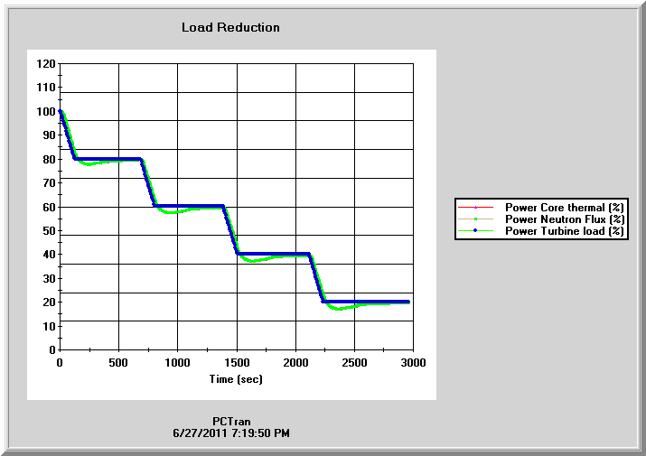
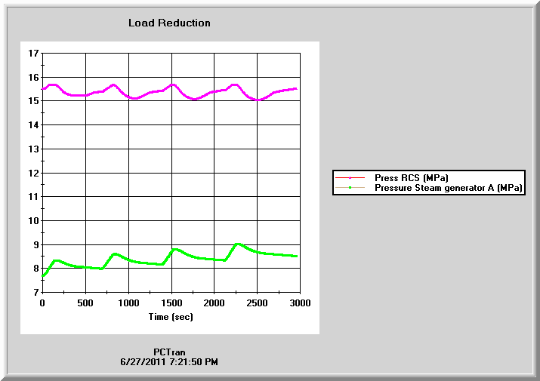

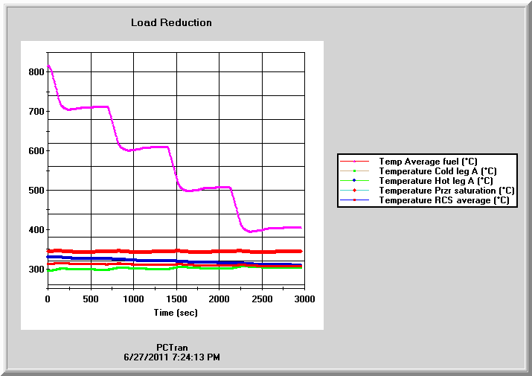
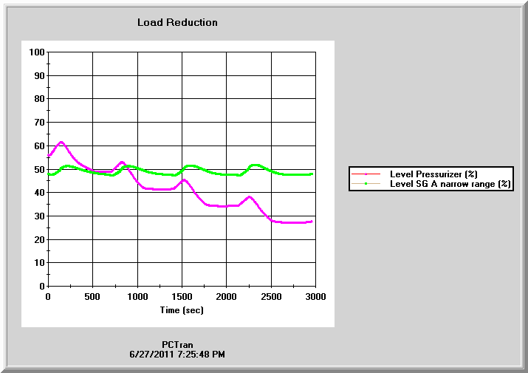
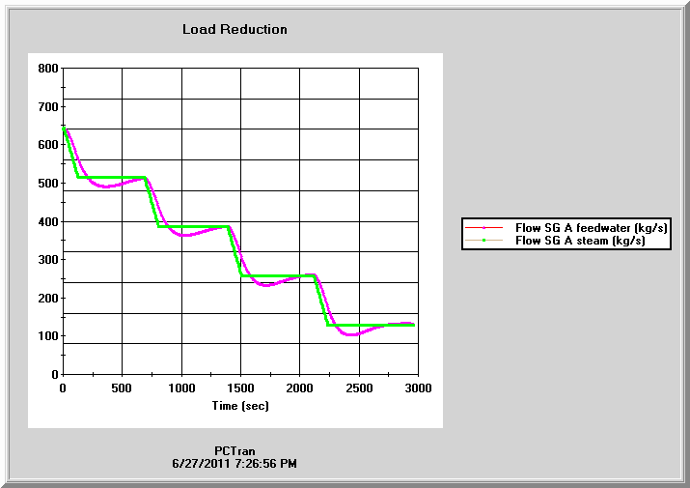
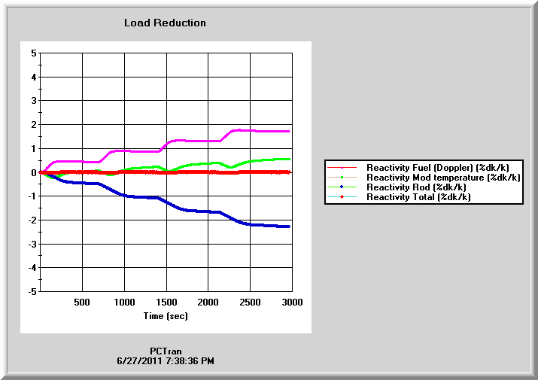

Shutdown and Cooldown

The reactor is scrammed manually till a stabilized at hot shutdown condition with the steam dump system controlling the secondary side. About 1 hour later the pressurizer heaters are disabled and the spray is turned on to depressurize the primary side. The spray is throttled first at about 10% opening and gradually increased to control the coolant subcooling margin or the pump’s NPSH. Then clicking on the Tavg control button and typing in a 50ºC/hr cooldown rate, the plant is cooled down as below.

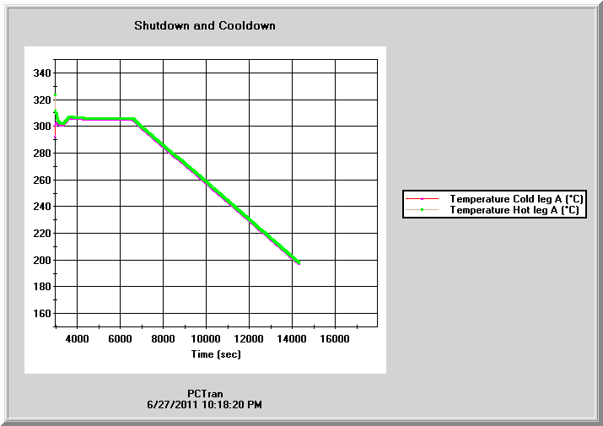

The following Figure 5.4.3 from the EPR design control document shows cooldown from 575ºF to 250 F in approximately 3.5 hours. The rate is ( 575 – 250 ) /3.5 = 64.3º F or 35.7ºC/h. Had we taken the 3-hour hold after shutdown and same cooldown rate, we could reproduce identical cooldown curve.
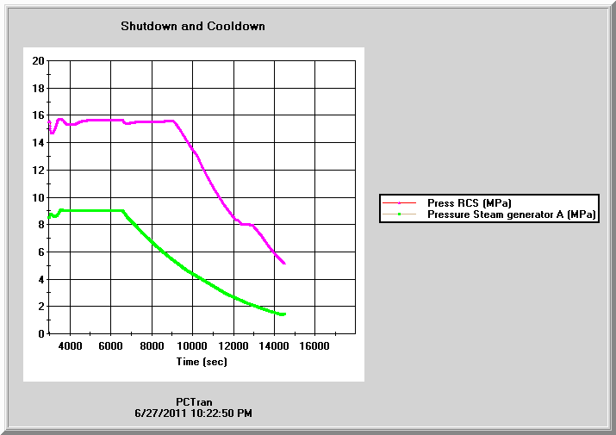
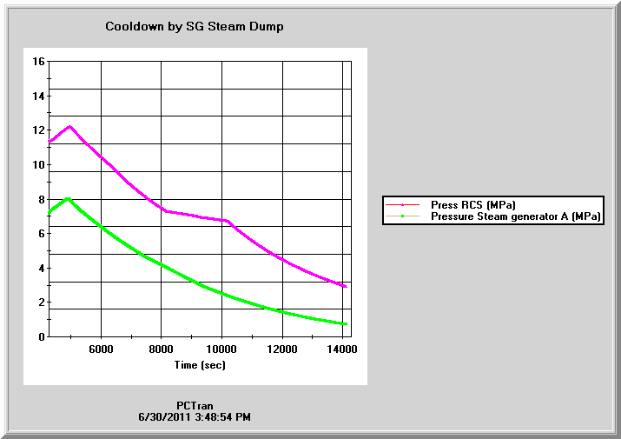

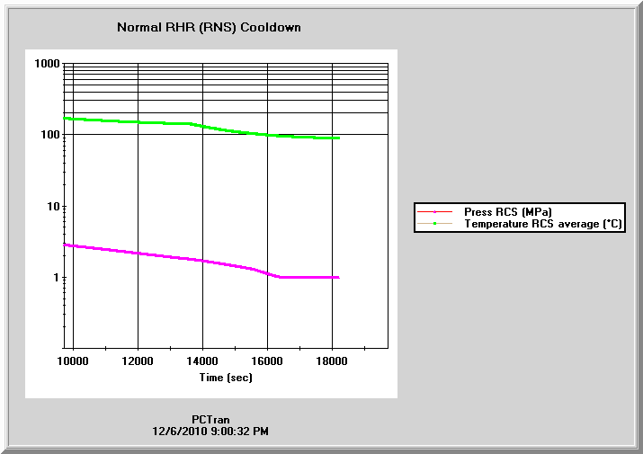

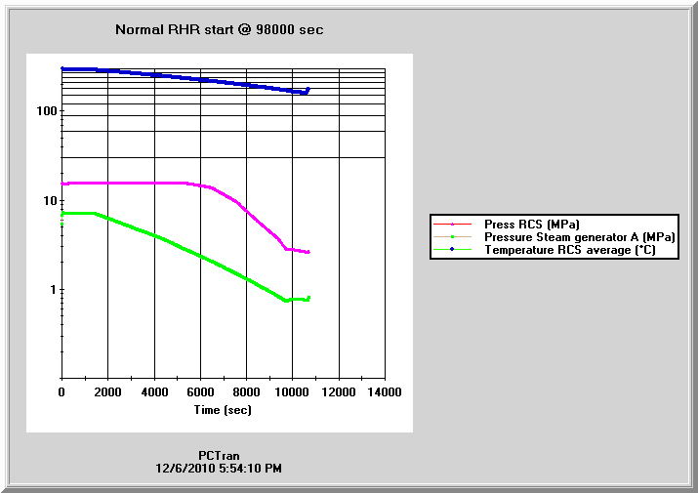
The normal residual heat removal system (RHR) cut-in condition is primary coolant below 450 psig and 350ºF (3 MPa and 176ºC). At that point, both side MSIV are closed and RC pumps are tripped. Two of the RHR pumps are turned on in the shutdown cooling mode. The auxiliary pressurizer spray is used to depressurize till atmospheric pressure. Operator should trip all operating RCP’s, close the MSIV’s and isolate all FW pumps.

